Question : 1
Create a Python script called playlist_stats.py that takes a list of daily Spotify song play counts (e.g., [120, 135, 150, 200, 120, 90, 200]) and calculates the mean (average) number of plays :

plays=[120,135,150,200,120,90,200]
mean=sum(plays)/len(plays)
print(f"Spotify Daily Play Counts:{plays}")
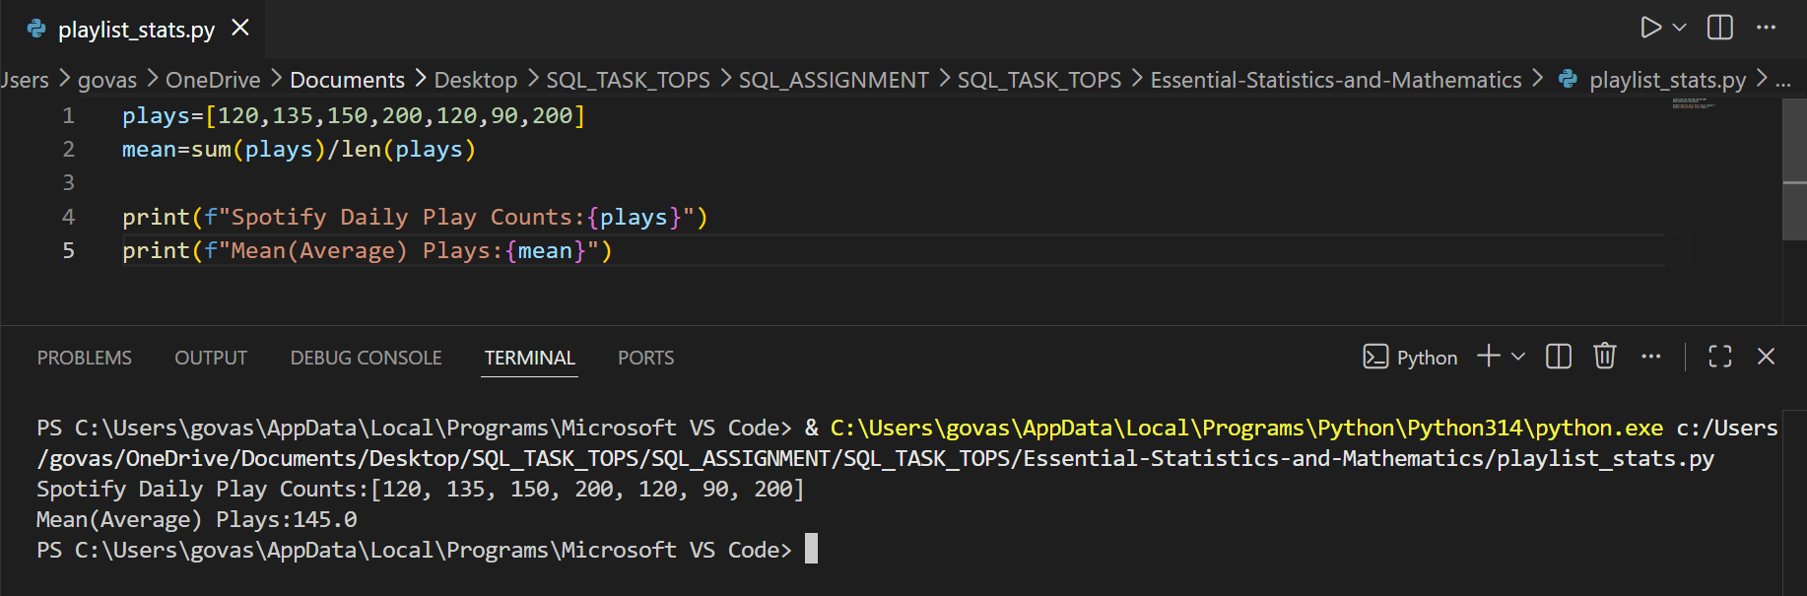
print(f"Mean(Average) Plays:{mean}")
Explanation :
Mean = Sum of all values ÷ Number of values
Question : 2
Given the following array of delivery times (in minutes) for Zomato orders: [30, 25, 40, 35, 30, 45, 30], write code to find the median delivery time and print it :

delivery_times=[30,25,40,35,30,45,30]
delivery_times.sort()
n=len(delivery_times)
median= delivery_times[n // 2]
print(f"Sorted Delivery Times:{delivery_times}" )
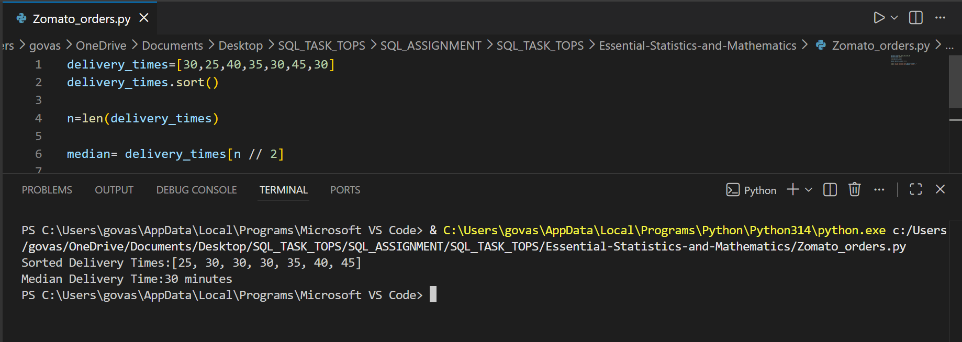
print(f"Median Delivery Time:{median} minutes")

Explanation : There are 7 values, so the middle value is the 4th value = 30

Question : 3
Write a function most_common_rating(ratings) that takes a list of Flipkart product ratings (e.g., [5, 4, 4, 3, 5, 4, 2, 4]) and returns the mode (most frequent rating) :
def most_common_rating(ratings):
return max(set(ratings),key=ratings.count)
ratings=[5,4,4,3,5,4,2,4]
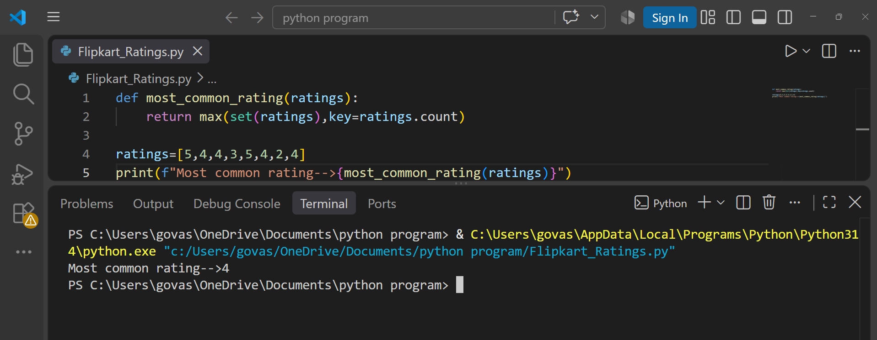
print(f"Most common rating-->{most_common_rating(ratings)}")

Explanation : The rating 4 appears four times, which is more than any other rating.

Question : 4
Given three lists representing YouTube video views for three different channels, compare the mean, median, and mode for each channel, and decide which channel's data is most affected by Outliers :
<br><br><em><strong>Hint:</strong> Try using one list with a very high value (e.g., [100, 120, 110, 105, 5000]) to see the effect on mean vs median.</em>

import numpy as np
from statistics import mode
channel_A=[100,120,110,105,5000]
channel_B=[100,120,110,105,115]
channel_C=[100,100,110,110,120]
channels= {
"Channel A":channel_A,
"Channel B":channel_B,
"Channel C":channel_C
}
for name,views in channels.items():
print("\n",name)
print("Mean:",np.mean(views))
print("Median:",np.median(views))
try:
print("Mode:",mode(views))
except:
print("Mode: No unique mode")

Channel A is most affected by outliers because it contains the extremely high value 5000.

The mean increases from around 110 to 1087, while the median remains 110. This shows that the mean is strongly affected by extreme values, where as the median is much more resistant to outliers.

Question : 5
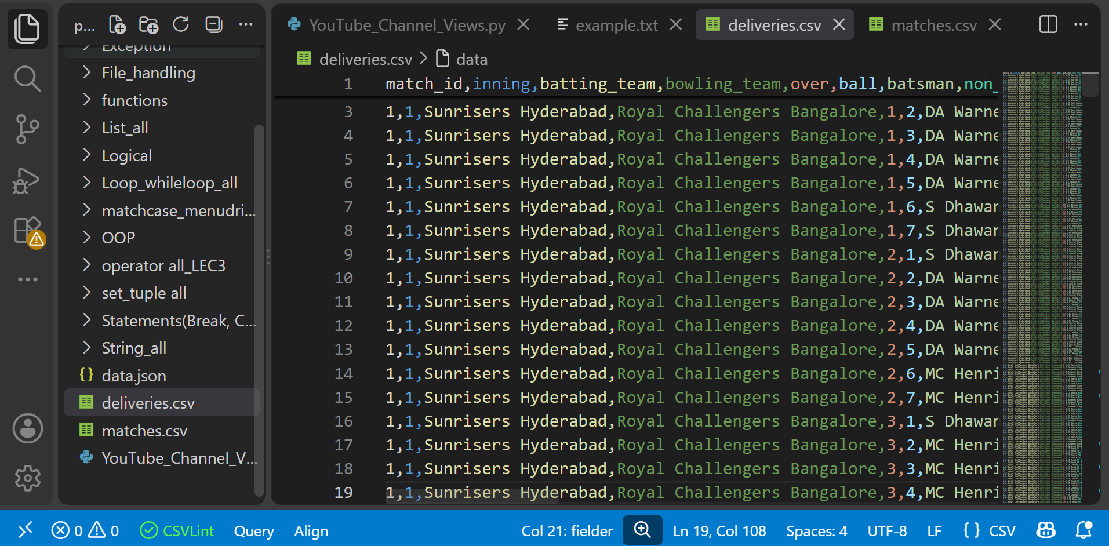
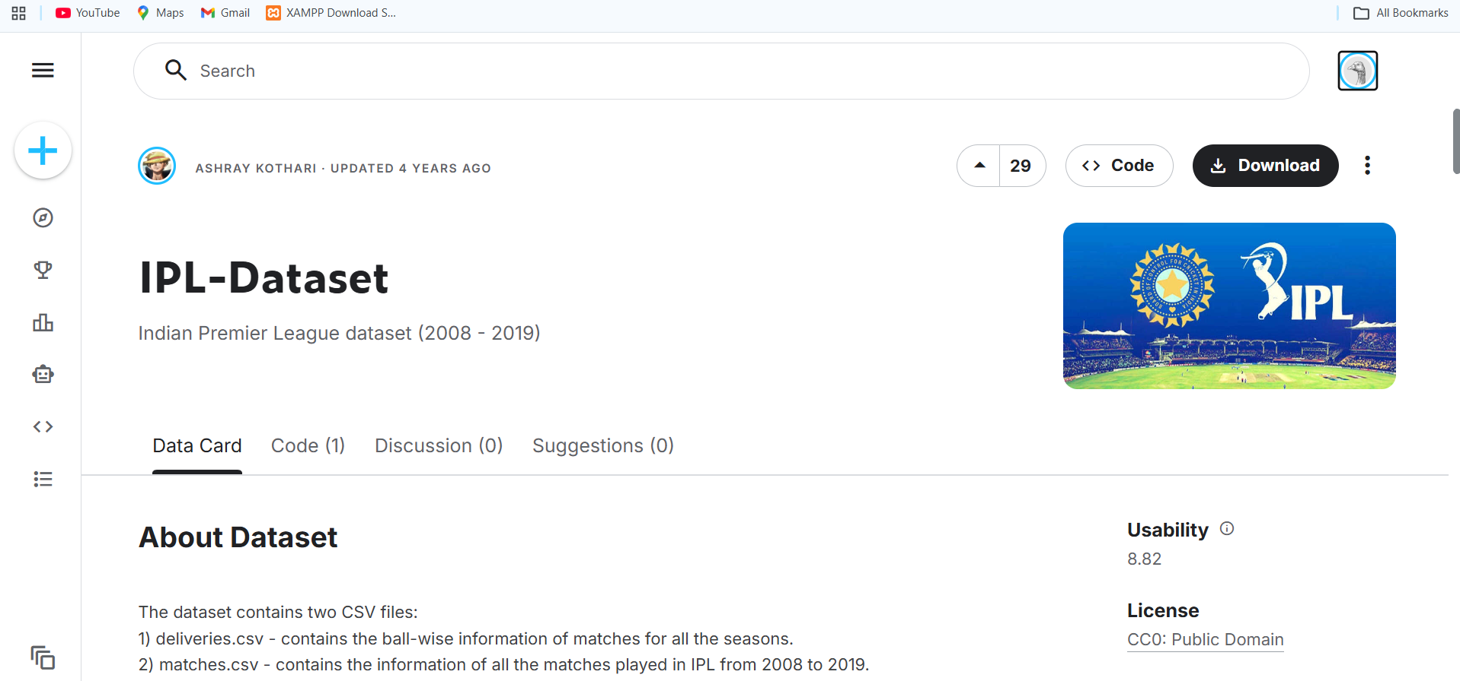
Pick any real dataset from Kaggle or UCI (e.g., IPL player runs, Swiggy restaurant ratings, or movie box office collections), load it using pandas, and display the mean, median, and mode for one numeric column of your choice :

import pandas as pd
df = pd.read_csv("matches.csv")
print(df.columns)
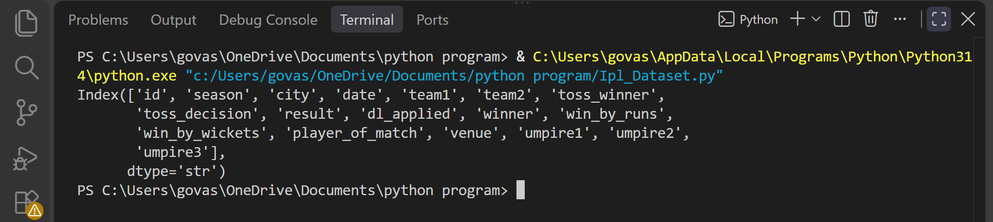

import pandas as pd
df = pd.read_csv("matches.csv")
runs = df["win_by_runs"]
mean_runs = runs.mean()
median_runs = runs.median()
mode_runs = runs.mode()[0]
print(f"Mean:{mean_runs}")
print(f"Median:{median_runs}")
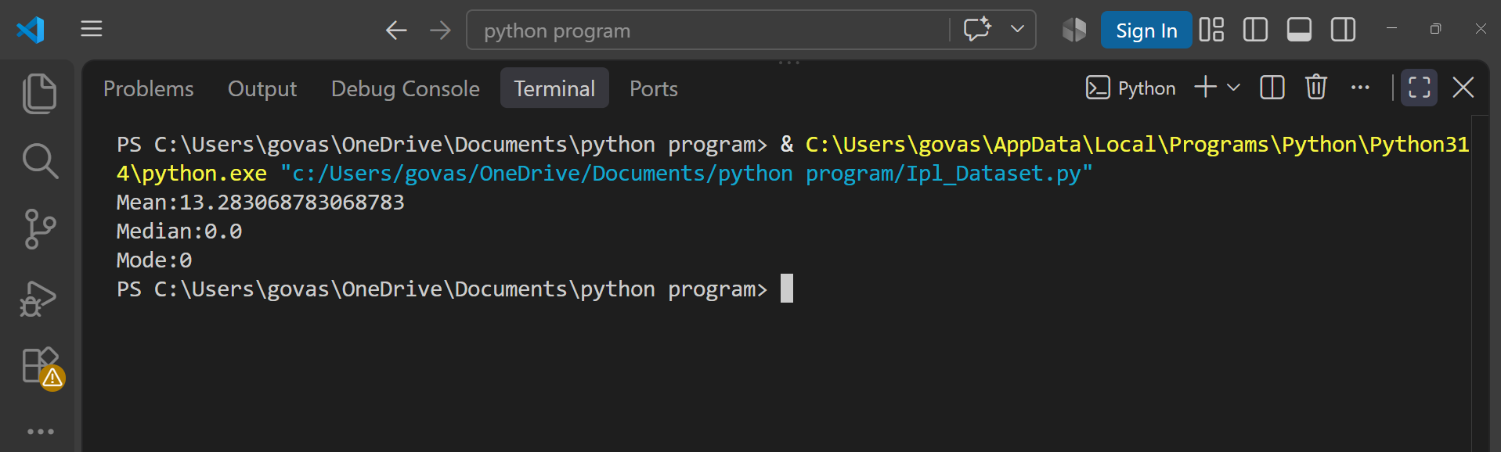
print(f"Mode:{mode_runs}")
The mean number of runs by which matches were won is approximately 13.28. The median and mode are 0, because many IPL matches were either won by wickets or had no run-margin recorded.

